Creative Holistic Integration (CHI) Wholeness Exercise From Holistic Self-Care Tools for Caregivers by Suchinta Abhayaratna, Th.D.

TORUS MANDALA VISUALIZATION
Observe yourself: 0 = best; 10 = worst – What number are you?
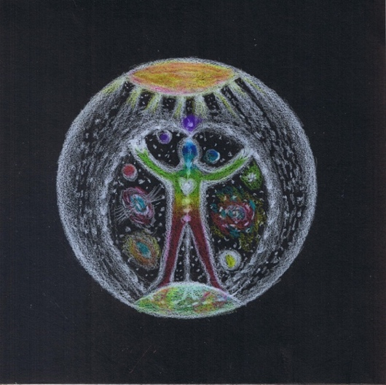
Visualize yourself with your heart at the center of a big black circle.
Inhale and exhale as if through your heart center about 5 times. As you breathe in you receive energy from all that is around you. As you breathe out you give energy to all that is around you. With each breath, focus deeper and deeper into your heart.
From your first breath to your last, your life is a series of giving and receiving energy.
Take a deep breath in, and when you exhale, send an explosion of light into the black circle.
The lights stick onto the blackness...like stars...each light a sun surrounded by its own family of planets - YOUR Universe...your energy field.
Breathe in Universal Energy from the top of your head, through the central channel of your body, into your heart and out through your legs and the soles of your feet into the Heart of Earth.
Breathe in Earth Energy up from the Heart of Earth, up to your heart from the outside of your body, filling the lower half of your circle with light.
Breathe out from your heart, filling the upper half of your circle with light, sending it up to the great light above you.
This pattern of energy movement is called a Torus. It’s how energy moves in EVERYTHING… From the smallest atom to our cells, our bodies, our earth and everything including the universe - it is how energy flows and moves.

Inhale: “I am...” Exhale: “That.”  Inhale: So… Exhale: Hum.
Continue this (Torus) breath pattern and the mantra (focus phrase) slowly and deeply for about 5 minutes...or as long as you wish. Doing this, you are consciously align yourself with the pattern of energy as it flows through everything. You can do this exercise as many times a day, for 5 minutes at a time.
Observe yourself: 0 = best; 10 = worst – What number are you at now?

Available soon at Amazon.com and other online bookstores. Also at www.chisuchinta.com/
A breath mantra from the ancient Siddha healing tradition of India. It means “I am That/ Other/Everything.”

